School Ties

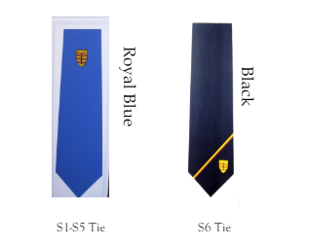
Every pupil is given a tie free of charge when they join the school.
Replacements for lost school ties can be purchased directly from the school office at a charge of £5.00 each.
S6 pupils can exchange their blue tie for a senior black tie when the start S6.

Benefits/advantages of school uniform:

- Encourage a sense of belonging and pride in the school.
- Enhance the image of the school in the local and wider community.
- Improve security on excursions through easy identification of Drummond pupils
- Improve security in school through easy identification of intruders.
- Discourage bullying and victimisation which may arise from pupils not having certain clothing or footwear.

Drummond Community High School
41 Bellevue Place
Edinburgh
EH7 4BS
T. 0131 556 2651

E. admin@drummond.edin.sch.uk
https://drummondhigh.org/



UNIFORM GUIDELINES
Drummond Community High School is committed to a school dress code. We want pupils to be proud to be identified with their school. We aim to prepare pupils for the world of work where a dress code is a common feature; to improve the image of the school in the local community; and to be able to recognise members of our school community for the purposes of security. We ask parents and carers to support the school in encouraging the wearing of school uniform.

DCHS Uniform Policy
This is a definitive list of the uniform items that are acceptable in Drummond CHS. Thank you for supporting us in ensuring that pupils adhere to our uniform policy.
White shirt and blue tie (black tie for S6) should be accompanied by:
- Black cardigan/jumper/tank top
OR
Drummond school hoodie (embroidered with the school badge)
- Black formal trousers
- Black skirt of an appropriate length with plain black leggings, black tights or black socks
- Black or white Hijab or Dupatta
- Plain black shoes/black trainers
All S6 pupils are expected to wear a black blazer, ordered through the school. S4 and S5 may wear blazers if they wish to.
A school bag must be brought to school every day to ensure the safekeeping of ipads and chargers during the journey to and from school.
School Hoodies

From August 2023, school-branded Hoodies are accepted as part of the Drummond school uniform; this is in response to a strong case presented to the school staff and Parent Council by the Pupil Leadership Team.
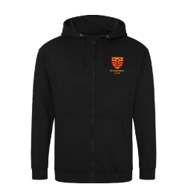

All non-Drummond hoodies, outdoor clothing (including hats/caps) and jackets/coats must be removed in class.

Please note that the following are not acceptable as part of Drummond’s dress code:
- Non-Drummond hoodies
- Polo shirts
- Black shirts
- Jeans/denim trousers/combat trousers
- Jogging trousers/tracksuits

Please note that all pupils should come to school dressed in uniform every day and then change into PE kit in the changing rooms when they have their PE lesson.
