Parent Council minutes

11 May 2021

Attendees:

- Jodie Hannan (Outgoing Headteacher)
- Rachel Robertson (Incoming Headteacher)
- Deirdre Henderson (Chair)
- Marie Hernandez (Vice Chair)
- Nicola Clark-Tonberg (Secretary)
- Denise Padgett (Treasurer)
- Michael Paley (Pupil Support)
- Shona Sloan (Depute Headteacher)
- Sandra Bagnall, Anne Hay, Catriona Scott, Jenni Longstaff, Rachel Blythe, Abigail Bremner, Lucy Richards, Shian Holt, Yahya Barry (parents and carers).

1. Welcome

In the light of the coronavirus pandemic, this meeting was conducted by Teams.

2. Apologies

There were no apologies.

3. Minutes of the last meeting, and matters arising

The minutes of the last meeting were agreed. No matters arising. Catriona and Denise confirmed the minutes were accurate.

4. Headteacher’s Report


Parent Council & AGM Tuesday 11 May 2021
Headteacher’s report

Staffing
- Rachel Robertson, DHT at Liberton High School, has been appointed to Headteacher of Drummond commencing August 2021.
- A full time Teacher of French & Spanish has been appointed to commence in August 2021.
- Mrs Davis, full time permanent Teacher of English commenced Tuesday 4 May.
- We are currently advertising for a part time ICT technician to commence August 2021.
- A permanent full time PSA advert is also imminent.

SQA & ACM
- We are currently gathering evidence for the ACM as per SQA and CEC guidelines. All S4-S6 parents and pupils were invited to an ACM information session last night, and the slides will now be emailed out.
- Additional inset days for staff only- Tues 25 May & Wed 9 June

Change of timetable & coursing
- All current S2- S5 have been coursed for session 2021/22
- Monday 14 June for all S1-S5 pupils.

P7-S1 transition
- Virtual and cluster primaries are following CEC’s ‘Moving Up’ programme.
- P7 Parents’ Evening on Wednesday 9 June 6pm.
Review of the year and looking ahead…….

What a year that was! And what can we say that’s not already been said!

Jodie confirmed that city-wide P5 – S6 pupils will be given one-to-one devices, funded by the Council. It’s important to retain the digital upskilling that has been gained.

Council will be focusing on Equalities, The Rights of the Child, Rights Respecting Schools, so Drummond is in a good place to take much of this forward and build on the strides that have already been taken.

Rachel and Jodie both referenced how engaged, positive and impressive the Drummond young people are and what they’re looking for in school improvement.

Denise would welcome introduction of basic IT knowledge for pupils to make the most of the new devices.

Jodie confirmed that training will be available for pupils and families.

Edmund asked about the provision of IT support for the new devices. Jodie confirmed there is one staff member in each department as digital support. Unfortunately Covid meant that the ICT Technician was unable to be in school, so an advert is being placed to recruit into this role. The Council’s role will be to rollout the devices only.

Deirdre referenced reports today of pupils sharing the content of SQA assessments with others and the Council’s unwillingness to engage with this unforeseen circumstance.

5. Heads of School and Pupil Voice

No pupils were present, and adverts for Prefects and Heads of School will be issued shortly.

Jodie praised the current Heads Andie and Connor, but recognised their role had been curtailed this year due to Covid restrictions and home learning.

Deirdre mentioned that it would be valuable to retain the link with Leith and New Town Community Council and to have a young person on the committee, with appropriate support from an adult.

6. Growing and Cooking Project

Rachel talked the group through her report, included in full below.

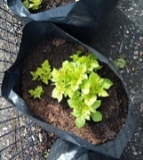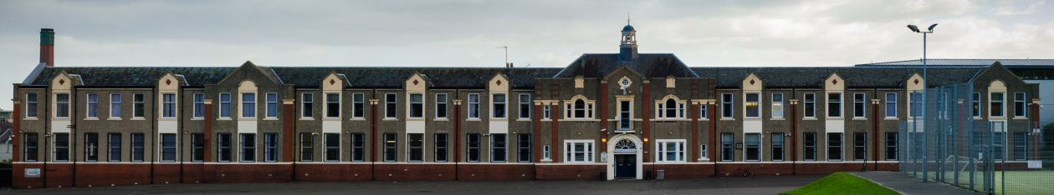
Partners’ Report: ‘Growing and Cooking Project’
Drummond Community High School Parent Council meeting of Tuesday 11/05/2020
(from Rachel A. Blythe)

Background
The “Growing and Cooking Project” is currently a partnership with 4 partners: Broughton Primary School Parent Council; Leith Walk Primary School Parent Council; Saheliya (a wellbeing support organisation for ethnic minority women); and Drummond Community High School Parent Council. The partnership was set up in February 2019, with some funding from Leith Chooses http://www.leithchooses.net/ Since December 2020, Broughton Primary School Parent Council has also been liaising with Abbeyhill Primary School Parent Council on gardening, planting and a range of other activities.

September 2020 to May 2021:
- In Autumn 2020, Broughton Primary School planted some quick growing carrots and new potatoes, with December 2020 harvests. Some indoor herbs were also planted. Primary 3, Primary 5 and Language Class children took part.
- In October 2020, the planters in Broughton Primary School’s ‘ex-bowling green’ green space were uncovered, with the aim of bringing these back into use. This was carried out at weekends, involving parents and children from the school and the company “Aura of Eden” https://www.auraofeden.co.uk/
- Broughton Primary School Parent Council has been liaising with City of Edinburgh Council and the architects involved in developing the Powderhall ex-bowling green area, to ensure, among other things, that the planters and the apple trees on this ground are maintained, as available to the school.
- In December 2020, 3 apple trees were replanted in the Broughton Primary School playground, being moved from large pots to growing directly in the ground. The company “Aura of Eden” very kindly contributed free labour, for this activity.
- In January 2021 and onwards, Broughton Primary School Parent Council; Leith Walk Primary School Parent Council and Abbeyhill Primary School Parent Council have been liaising about the planting/growing of free potatoes, gained via the organisation https://www.growyourownpotatoes.org.uk/ This organisation gives out potatoes to primary schools, if you ask for them, leading to a competition on the weight of your potato harvest in June each year.
- Throughout January to March and now into May 2021, the ethnic minority women’s organisation, Saheliya, has been running an online course about gardening, with assistance from the Botanic Gardens. I’ve also contributed some input to the course, on behalf of Broughton Primary School Parent Council.
- Leith Walk Primary School Parent Council have been regenerating the planters in their playground.
- Liaison by the 4 partners in the original Leith Chooses partnership, towards ensuring that all funding is spent.
- We have recently had very kind offer from Leith Community Growers’ Association/Edible Estates, in conjunction with Edinburgh Tool Library. They are organising an activity about the building of planters for distribution around Leith (they mean Leith in a broad sense, which takes in Drummond Community High School). The planters would then be used for growing, to brighten up the local environment. The plan is to distribute 100+ planters around Leith. We have been offered one for Drummond Community High School, one for Broughton Primary School and one for Leith Walk Primary School. (I am also hoping for one for Abbeyhill Primary School, but we haven’t quite been offered that yet.) There is a community effort to build the planters, which might be relevant, to woodwork in the school, or it might also be relevant to parents/staff from the school, who wish to learn these skills.

- Leith Community Growers Association says:

“The next steps here would be to initiate dialogue with one or some of the schools, which you mention and identify how many and what size of planter they would like. Options would be the bigger ones (approx 1m across) or the smaller ones suitable for windowsills (approx 50cm across, the ones shown in the video below). Then at a later date we can organise the specific dates to get together to build planters and put in seeds etc., and start promotion/publicity via whichever means.”
https://www.youtube.com/watch?v=4G9uwdgLSl4&fbclid=IwAR0iaIbOCxrLg50IMttvGze6wrpIPa0wINijC_c0F1agZmPxX-fyU1tw-W0

I would welcome views on how to take this one forward. Thank you

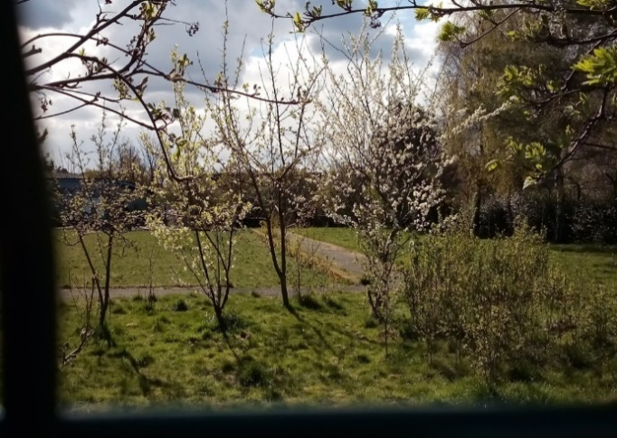 | 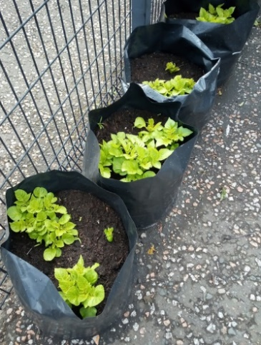
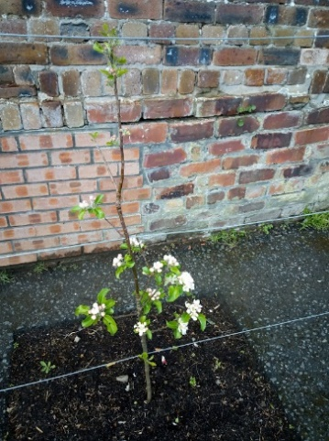 | 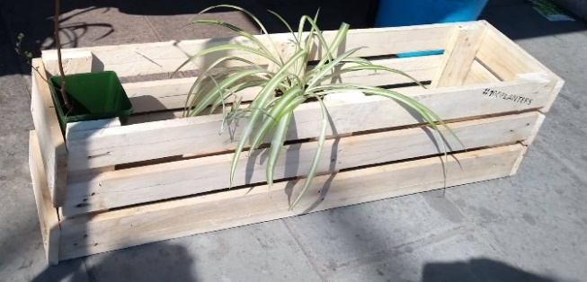

Rachel is picking up conversations about bringing some growing in to Drummond, and Denise suggested involving the Eco Club.

7. Promoting the school

A standing item. Jodie has her plans for how to carry on promoting school in current restrictions, including bringing back in-school visits when guidance allows.

Any creative ideas, please let Deirdre know.

8. Fundraising

A standing item. Nic gave an update that the Tesco Bags for Help application for Duke of Edinburgh equipment is still under consideration. Hoping no news is good news!

There has been a request for funding for Active Schools to meet costs for hiring space for example, although the Council has removed fees for pupils taking part.

For a 20 week course for basketball and 20 week for football would be £700 in total (£340 + £360) to be in place for next term.

Deirdre is going to lobby for matched funding from the Council first as they do have responsibilities to support young people being active.

Parents were supportive, but keen to consider the sustainability of future Active Schools and if there’s an expectation of paying out similar costs to keep the activity going.

Michael confirmed that the view from Active Schools is that this is not likely to be the case, and costs may reduce or funding won’t be needed.

Abi suggested we agree the full amount as a Plan B if the Council can’t/won’t fund. The majority of group agreed. Deirdre too take this forward.

Denise suggested re-instating the Saturday café once guidance allows.

9. Treasurer’s Report

Accounts were verified by Teresa Elsmore.

As expected, not much has happened this year with the funds.

We were able to provide the money for the teachers to get their flu jab when the council announced they would not be funding them last year.

The school ran an Anti-Racism campaign, and we donated the money to buy 2 x £20 Amazon vouchers for the winners.

10. Feedback from Council meetings

Deirdre will report back on future meetings, and ask for support from the group to share the load of attending meetings, especially when they clash with cluster primary or Parent Council meetings.

11. Future meetings

Jodie and Rachel to look at diaries and suggest dates.

12. AOB

Scottish Government’s Strategy for Autism was published in 2011 and feedback is sought from parents. Email hayley.mcmurray@ea.edin.sch.uk before 18th May.

Young Scot card – you can apply online and need a passport. Libraries are no re-opening and pupils can make appointments to go in and apply for their card.

13. Close of meeting

